**Latihan C++**

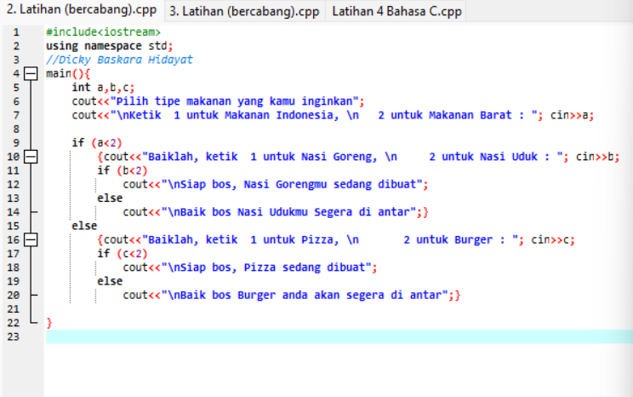

Jawaban Latihan 1 1

**LATIHAN C**

